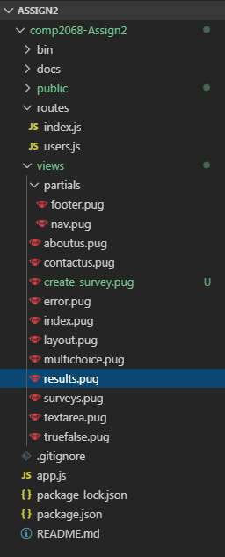

**Index:** Home page - Will have background image Tokyo1

**About Us:** Information about our survey site/company - Will have background image Tokyo2

**Contact Us:** How to contact

**Create Survey:** Page containing buttons to direct you to the correct survey type creation page

**Multichoice:** A page for creating multiple choice surveys

**Results:** View the results of the survey

**Surveys:** View created surveys

**Truefalse:** A page for creating true or false surveys

**Textarea:** A page for creating text-based surveys

Base Layout for Home, About, Contact

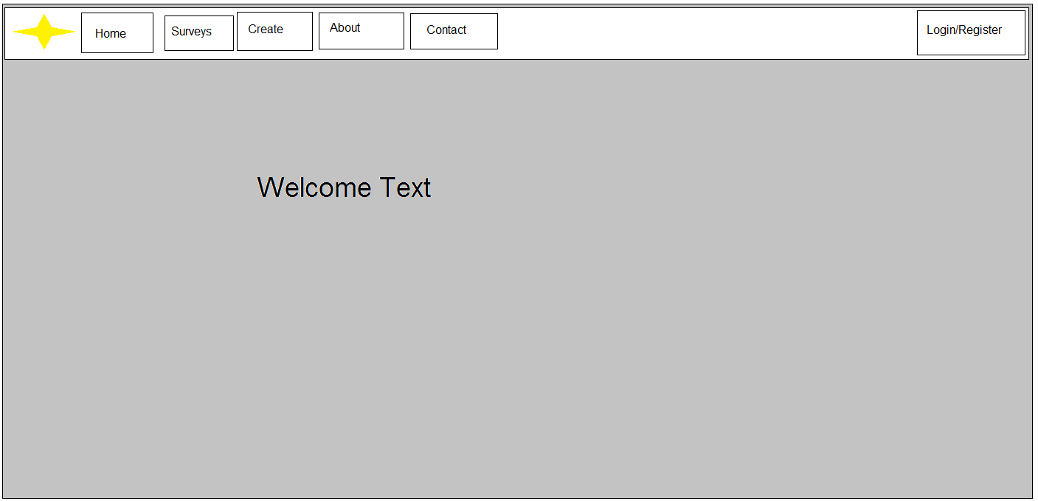

Surveys

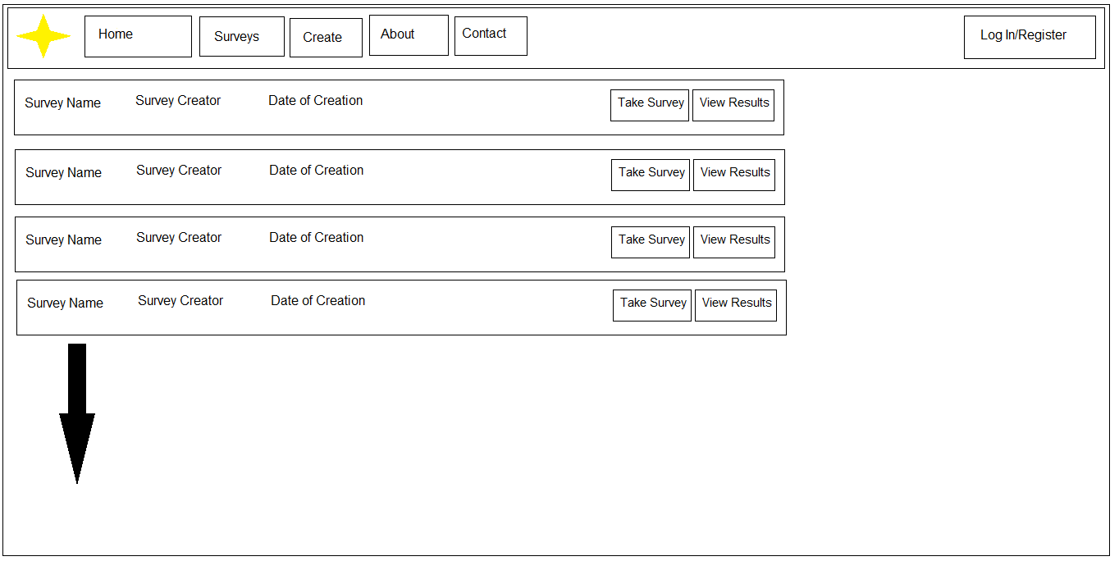

Create

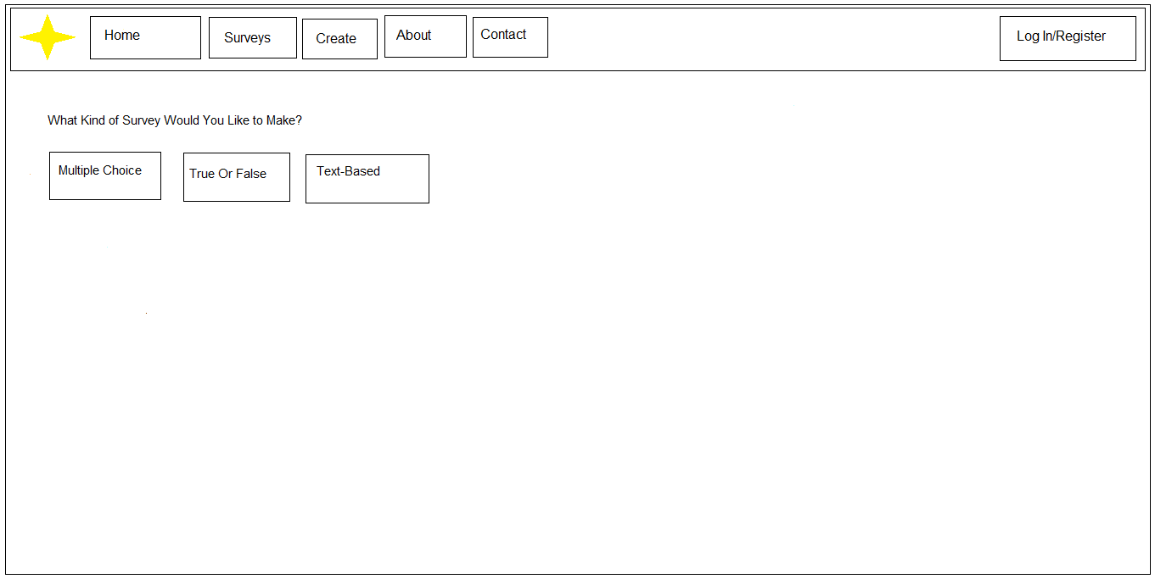

Results

